ASP.NET Dev Camp - Module 1

Microsoft Azure Portal Overview

Lab version: 1.0

Last updated: 1/13/2015

Estimated demo delivery time: **10 minutes**.



Contents

Overview 3

Prerequisites 3

Setup 3

Exercise 1: Creating a New Website Resource 4

Task 1: Browsing Available Resources 4

Task 2: Creating a New Website 11

Exercise 2: Touring the Microsoft Azure Management Portal 23

Task 1: General Usage Overview 23

Task 2: Startboard Customization 27

# Overview

In this demo, we will show how to load and work with the Microsoft Azure management portal, browse and spin up resources and services offered via the marketplace, as well as put some custom touches on a personal dashboard (called the Startboard).

# Prerequisites

The following are required to complete this demo:

* Internet connection
* [Microsoft Azure](http://azure.microsoft.com/en-us/pricing/free-trial/) subscription

# Setup

* Log into the Microsoft Azure subscription that you will be using for demonstration.
* Reset the Startboard to default by logging into the [portal](https://portal.azure.com/) and then clicking **Browse | Portal Settings**, followed by the **Restore Default** button.

# Exercise 1: Creating a New Website Resource

In this exercise, we will start by exploring the Microsoft Azure management portal while browsing available resources, services, and applications in the marketplace. The marketplace brings together many of the Microsoft and third party offerings into an easy to navigate listing, and now thanks to Azure Resource Manager, templates are provided that allow users to spin up and configure multi-resource applications and infrastructure with minimal effort. During our exploration, we will also spin up a simple Website resource to demonstrate that experience.

## Task 1: Browsing Available Resources

1. Log into the Microsoft Azure [portal](https://portal.azure.com/). The default view that we see after logging in is the Startboard. This Startboard contains tiles that provide at-a-glance insight into status and metrics, some of which are even automatically updated without user interaction. Each user can customize their Startboard as desired per subscription, as we will see later on.

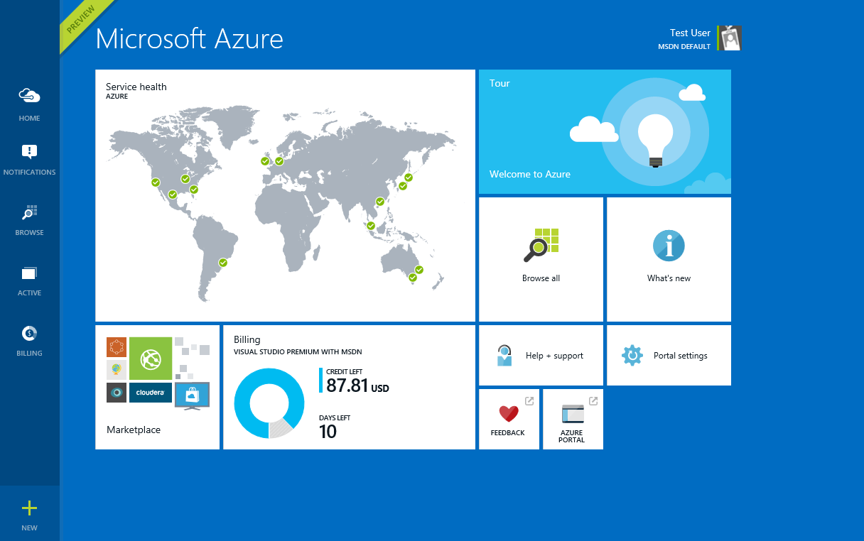

1. Before we dig in more and explore the portal in detail, let’s kick off the creation of a new Website resource. Click **New**.

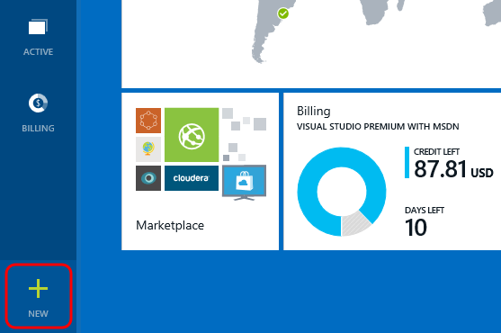

1. Some of the more common resource types are shown here, including a Windows Server virtual machine, SQL Database, and Website. Although we could easily kick off the Website creation process directly from here, let’s take a tour of the entire marketplace of resources that are available. Within the **New** blade, click the **Everything** link.
   * 1. **Note:** In the Azure management portal, you take “**journeys**” through data and configuration views, which are called “**blades**”.

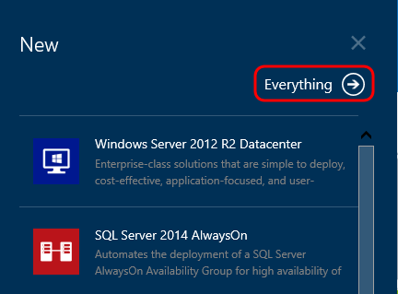

1. Here we can search for resources or alternatively drill into specific categories such as Virtual Machines, Web, Media, Data, and so on. Select the **Virtual Machines** marketplace category.

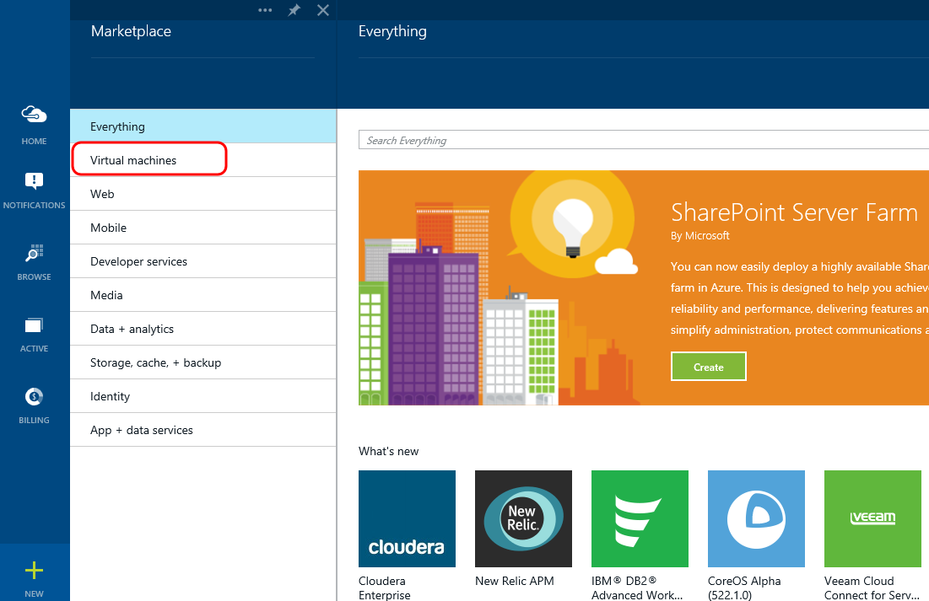

1. Scroll through the list of virtual machine templates that are available, provided by Microsoft and other third parties. You should be able to spot various Windows Server SKUs, Linux, database servers and so on.

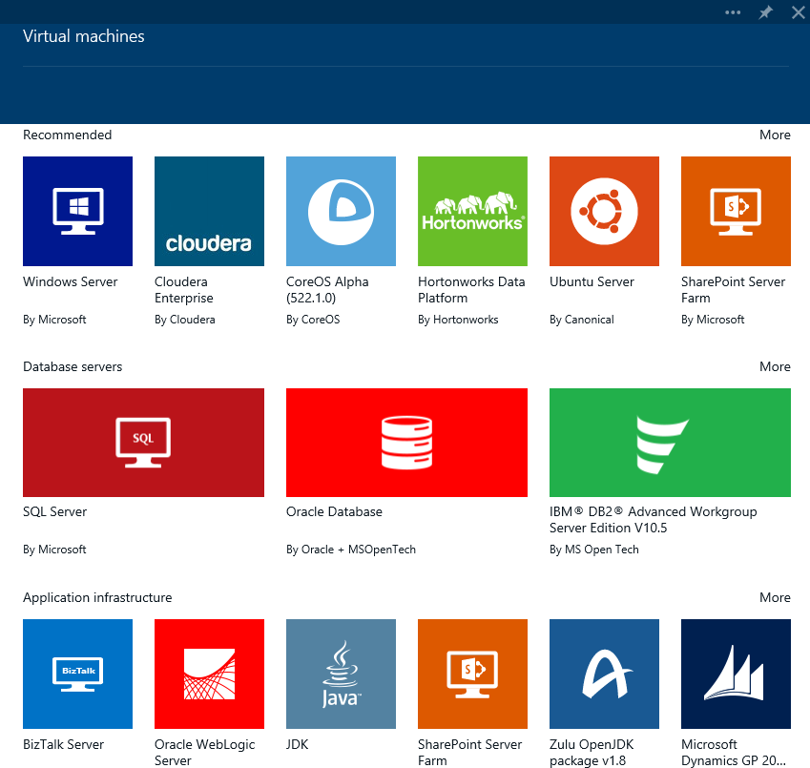

1. Select the **Mobile** marketplace category and take note of the options available including Mobile Service, Notification Hub, Scheduler, as well as other add-ons such as Service bus and SendGrid Email Delivery.

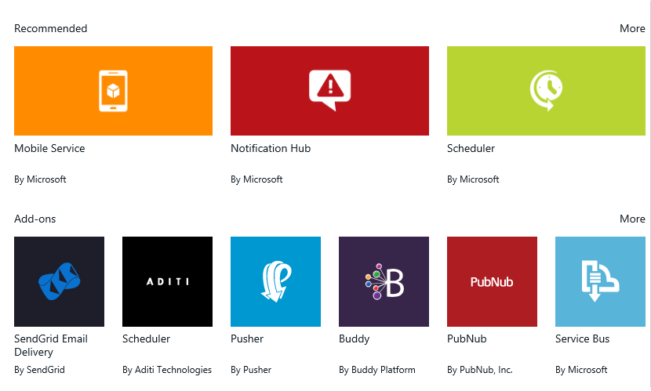

1. Select the **Developer Services** marketplace category and take note of the options available including Team Projects, Application Insights, and more.

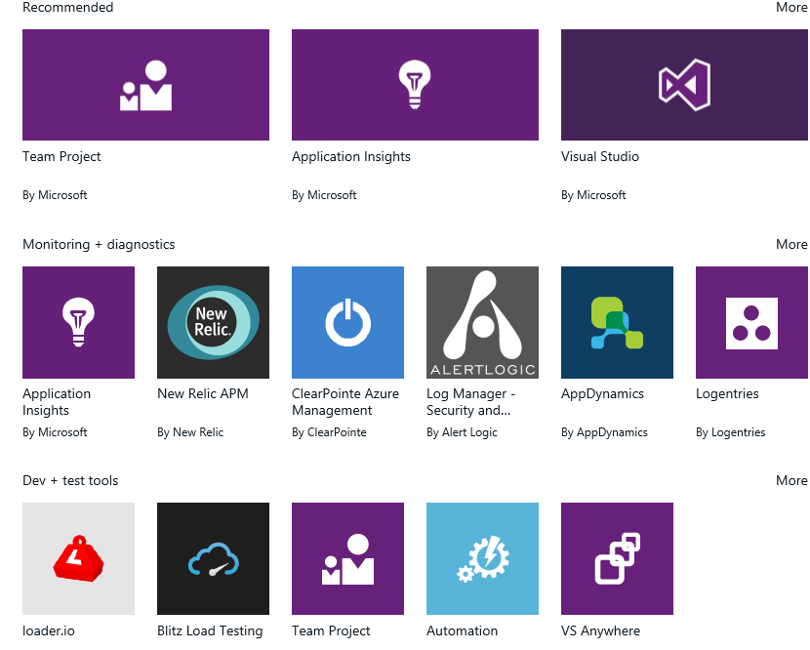

1. Select the **Data + Analytics** marketplace category, followed by the SQL Server option.

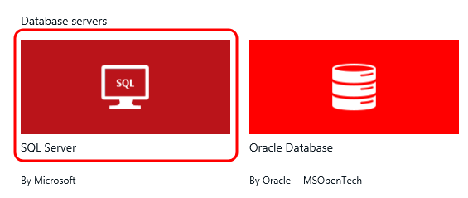

1. Note that we can choose from between a number of different SQL Server SKUs and versions.

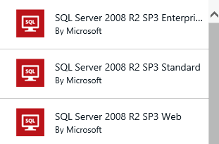

1. Although you can certainly spin up individual resources, it is important to point out that templatized groups of resources can also be provisioned. Click the **SQL Server 2014 AlwaysOn** option.

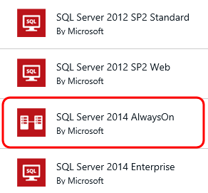

1. In the SQL Server 2014 AlwaysOn informational blade that opens, take note that this is a true template as it will result in the creation of multiple virtual machines joined to a domain, virtual network, storage account, and so on.

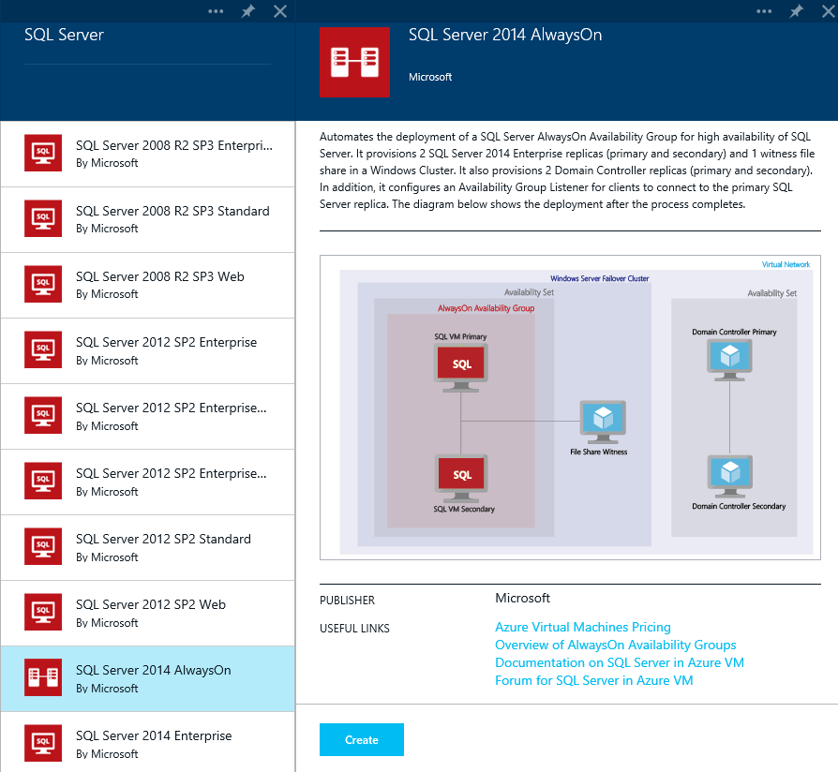

1. Take a few additional minutes to tour the available resources and application templates available in the marketplace. This includes Media Services, Storage, CDN, SQL Database as a service, Redis Cache, Active Directory, and many more services and applications.

## Task 2: Creating a New Website

1. Now let’s spin up a new Website resource. Click the **Website** tile from the **Web** marketplace category. We will be making extensive use of this resource in later demos.

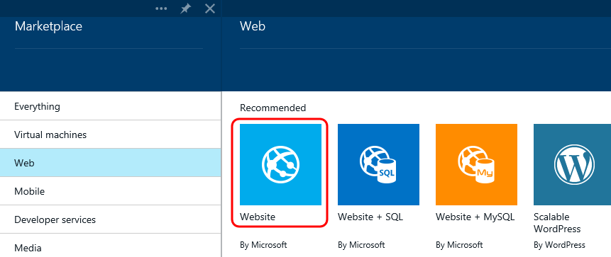

1. In the Website blade, click the **Create** button.

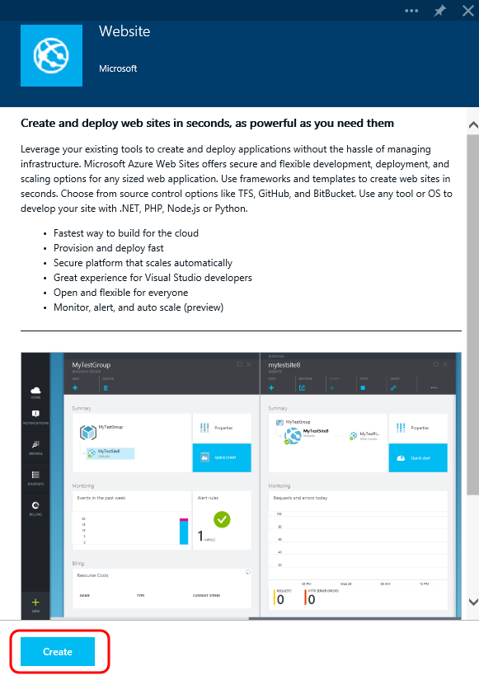

1. Provide a globally unique URL for the website.

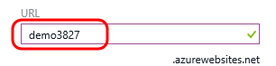

1. Although we could simply go with the default, click the **Web Hosting Plan** option to drill into the available options.

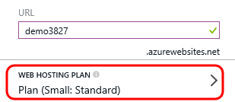

1. If we had an existing hosting plan available we could use that, but for our purposes let’s go ahead and create a new one. Scroll down and then click the **Browse All Pricing Tiers** option.

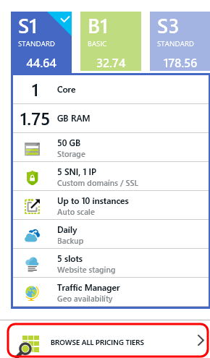

1. Take a look through the available tiers and pricing options while noting that each comes with different specs for cores, memory, storage, etc. Go ahead and select the **Free** option towards the bottom for demonstration purposes. Each subscription gets a limited number of these free Website resources, but as you can see they are very feature limited.

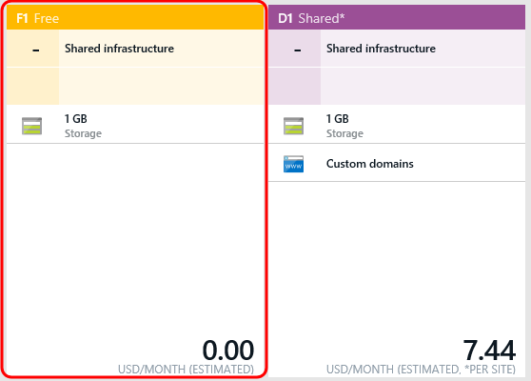

1. Click the **Select** button to finalize your selection.

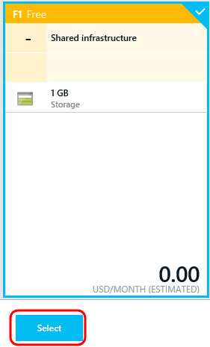

1. In the Web Hosting Plan blade, click the **OK** button to use the default name of “**Plan**” for the new web hosting plan.

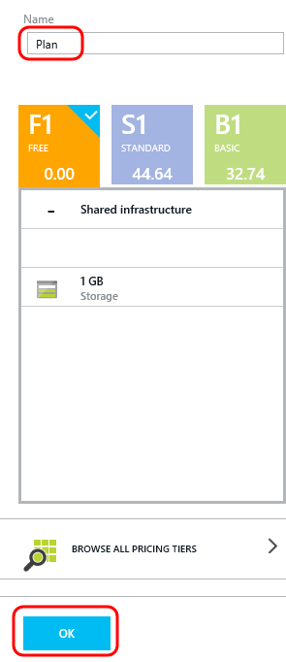

1. Click the **Resource Group** option. Resource groups allow you to group resources together for easier administration and monitoring. As we will see in later demos, this may be used to group all resources for an application or service together, e.g. you have a website, a database, and a storage account that you consider to all be part of the same single, logical application.

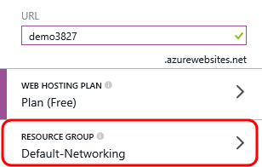

1. In the Resource Group blade, click the option to “**Create a new resource group**”.

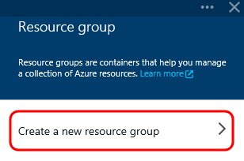

1. Provide a name of your choosing for the new resource group and then click **OK**.

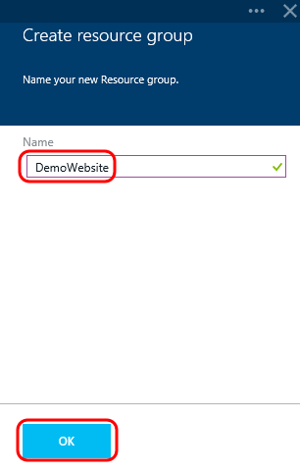

1. Click the **Location** option.

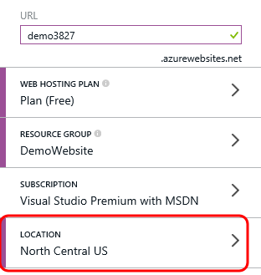

1. In the **Location** blade, select one of the available Azure datacenters from around the globe where the resource is to be provisioned.

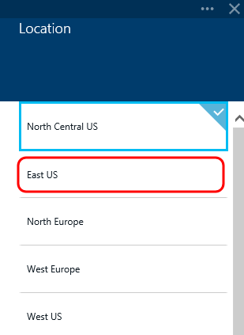

1. Note that the option to “**Add to Startboard**” is selected by default. Click the **Create** button to initiate the creation of the Website resource using the options that we provided.

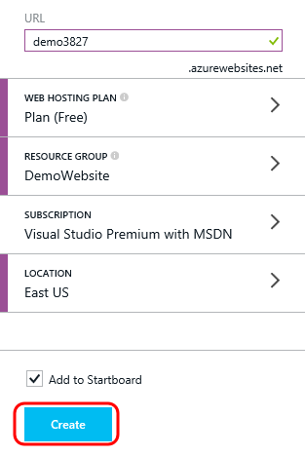

1. Note that a new tile was added to the Startboard, and that it provides a status notification informing us that the Website is being created.

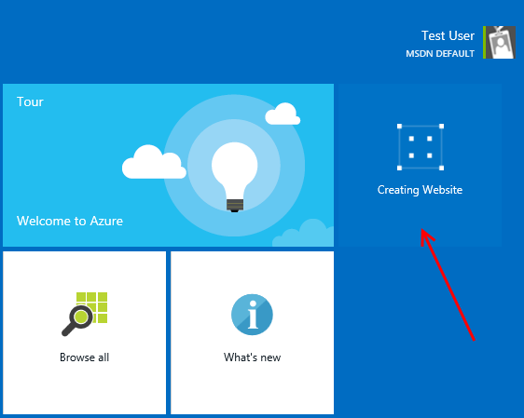

1. Once the Website resource is created, a new blade will automatically open.

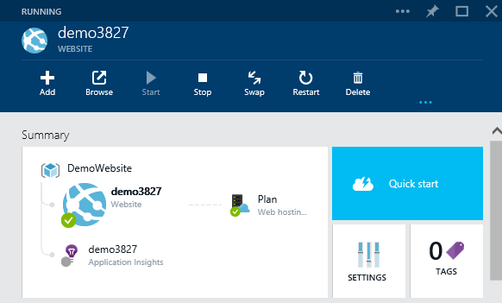

# Exercise 2: Touring the Microsoft Azure Management Portal

In this exercise, we will cover the navigation and usage basics of the Azure management portal, including some of the customization options available with the Startboard.

## Task 1: General Usage Overview

1. In the previous exercise, we ended with the creation of a new Website resource. Note that there is a notification hub that is exposed by clicking the **Notifications** button on the left-hand panel.

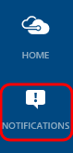

1. Note that we received a notification about the Website resource being created successfully.

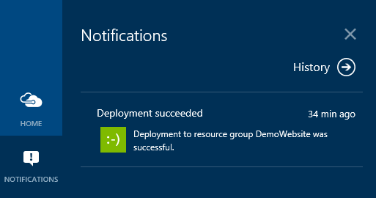

1. The Home button on the left-hand panel allows us to toggle between the current journey that we are on and the Startboard. Go ahead and click on the Home button once to view the Startboard.

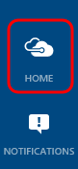

1. Click on the **Home** button one more time to return to the Website blade.
2. Click the **Browse** button.

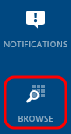

1. The Browse blade allows us to view most recently viewed resources, filter resources by type, or jump to a number of other views such as portal settings.

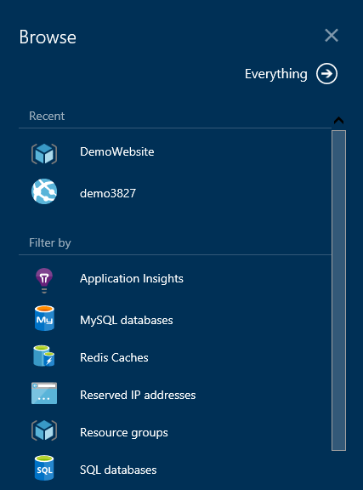

1. Close the **Browse** blade.
2. Click the **Active** button.

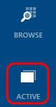

1. The Active blade shows a list of journeys that we have recently taken. We can click on any one of these to resume the journey at a later point in time.

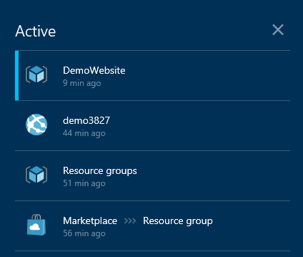

1. Close the **Active** blade.
2. Click the **Billing** button.

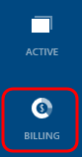

1. Click on one of the billing options (if you have one available to the user that you are logged in as).

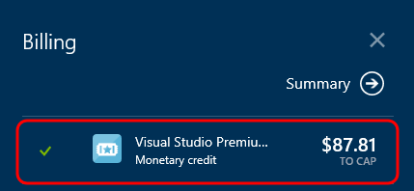

1. The Billing blade will show the burn rate, breakdown of current charges by resource type, as well as other billing properties. Your view will be different from the one shown below, as this one is associated with a MSDN subscription which provides a monthly credit (as opposed to a pay-as-you-go or other plan).

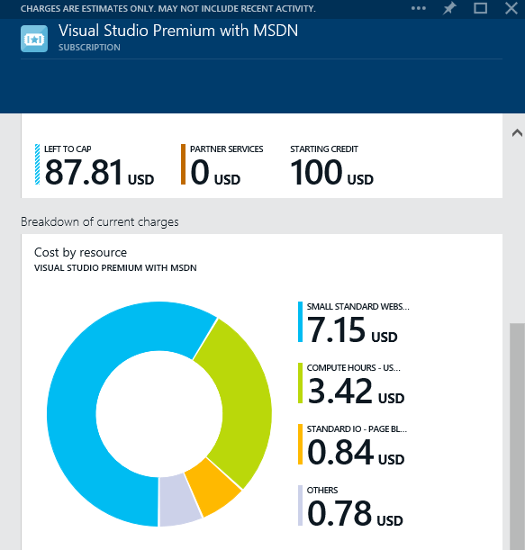

1. Close the **Billing** blade.

## Task 2: Startboard Customization

1. The Startboard itself is customizable per user and subscription, as we alluded to earlier. Let’s see this in action by first returning to the **Website** resource blade that we created earlier.

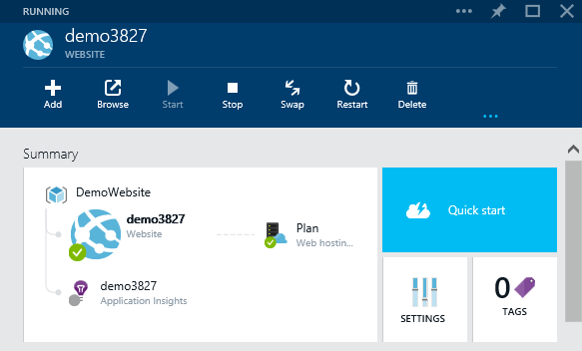

1. Many of the tiles shown on the resource blades, such as this Website, can be pinned and arranged as desired on the Startboard. **Right-click** on the **Requests and Errors** tile and select the **Pin to Startboard** option.

**Note:** Resource blades can themselves be customized by moving and re-arranging parts.

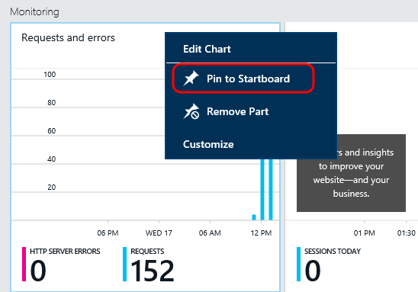

1. **Pin** the **Quotas** tile to the Starboard.

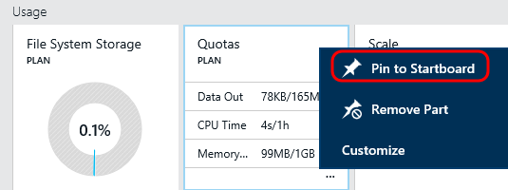

1. **Pin** the **Alert Rules** tile to the Startboard.

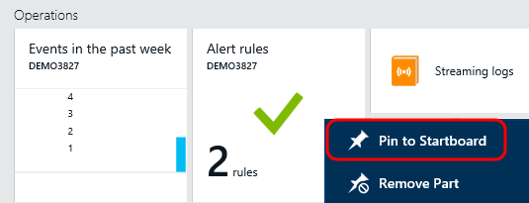

1. Click the **Home** button to return to the Startboard.
2. **Right-click** somewhere on the Startboard and select the **Customize** option.

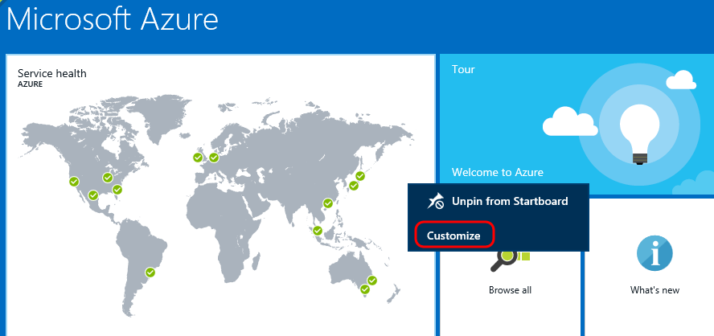

1. Change the size of the **Service Health** tile by clicking the **ellipses** button and then selecting the **Normal** option.

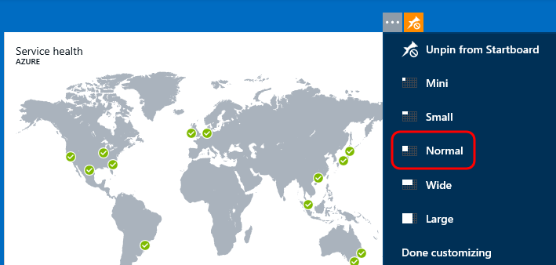

1. Unpin some of the default tiles such as Tour, Browse All, What’s New, Help + Support, Feedback, and Azure Portal to clean things up a bit. To do this, **right-click** on the tile and select **Unpin** from Startboard.

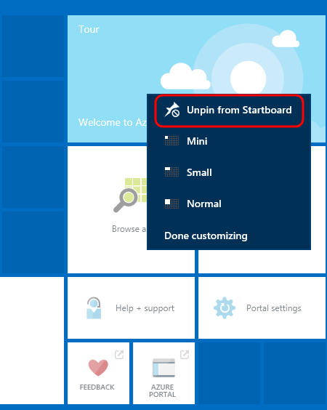

1. Alternatively, you can also select tiles and then click the **Unpin** button in the top-right corner.

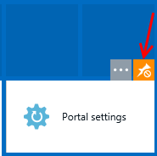

1. To move tiles around on the Startboard grid, simply drag and drop. Let’s go ahead and re-arrange the tiles that were added to the Startboard earlier so that it is more compact.

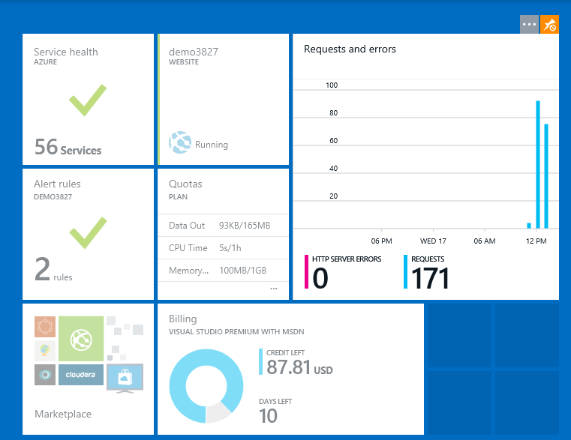

1. Once we are satisfied with our custom Startboard view, we click the **Done** button in the top-right corner.

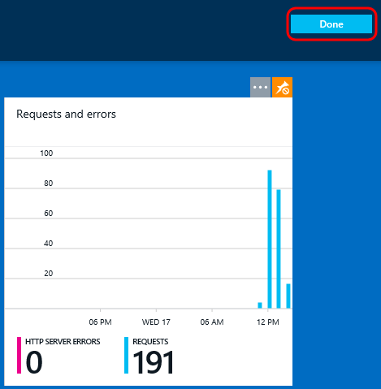

1. Now when we load the portal and view our Startboard, we can directly view and drill into what we are interested in monitoring with a single click.

